**Module 4: Route 53 Assignment**

**Problem Statement:**

You work for XYZ Corporation that uses on premise solutions and some limited number of systems. With the increase in requests in their application, the load also increases. So, to handle the load the corporation has to buy more systems almost on a regular basis. Realizing the need to cut down the expenses on systems, they decided to move their infrastructure to AWS.

**Tasks To Be Performed:**

1. Use the Route 53 hosted zone created in the assignment.

2. Route the traffic to an EC2 instance with an Apache web server running in it using its IP address.

**Problem 1 Solution:** Use the Route 53 hosted zone created in the assignment.

***Register a Domain with AWS & It Automatically Creates Hosted Zones***

**Step 1: Go** tothe **“Services”** section& **search** the **“Route 53”. Click** onthe **“Domain Names”.**

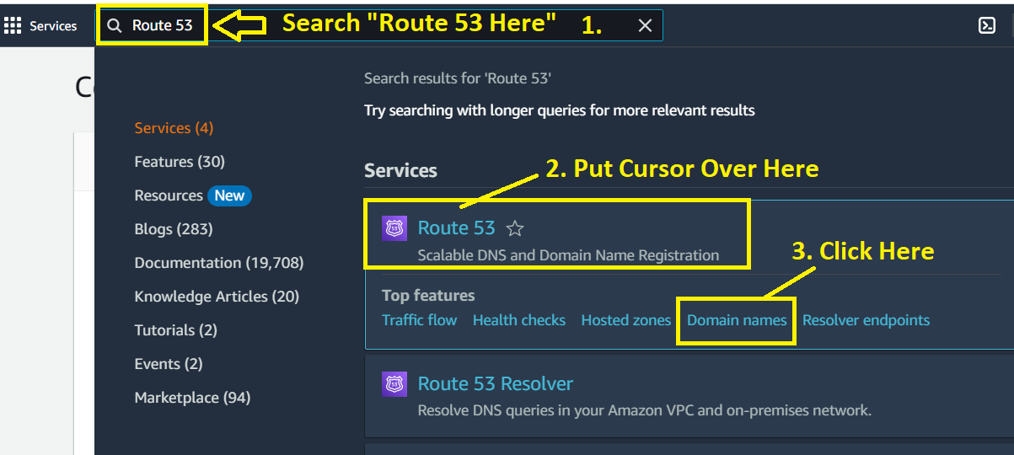

**Step 2: Click** onthe **“Register Domains”.**

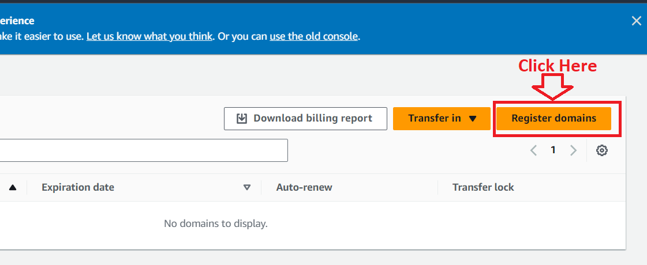

**Step 3: Search** the **domain** with **.click. They** will **charge** you **3$** only**. Put your domain “(visal.click)”** & **click** on **“Search”.**

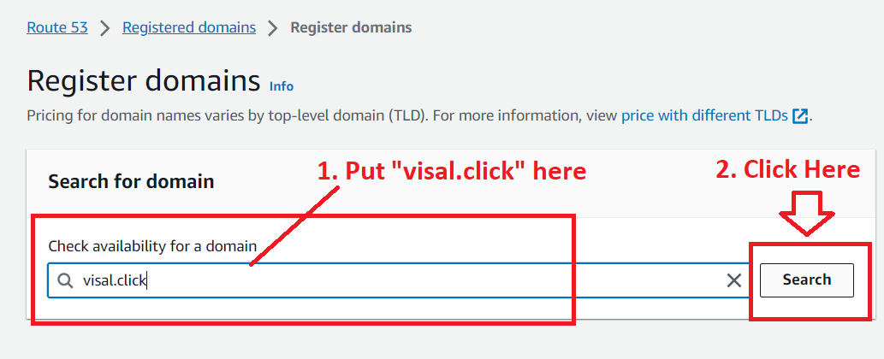

**Step 4: Click** on **“Select”.**

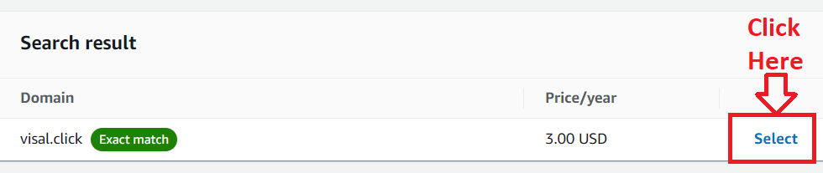

**Step 5: Click** onthe **“Proceed to Checkout”.**

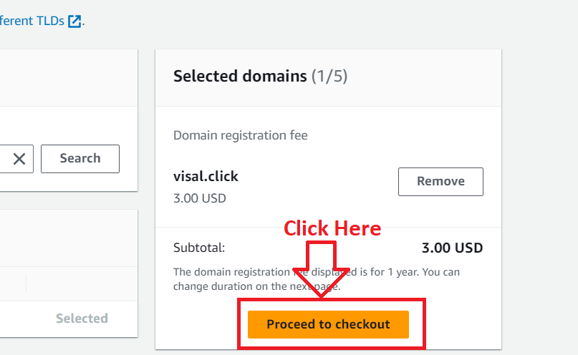

**Step 6: We** will **disable “Auto Renew” here** by **deselecting** this **option. Click** onthe **“Next”.**

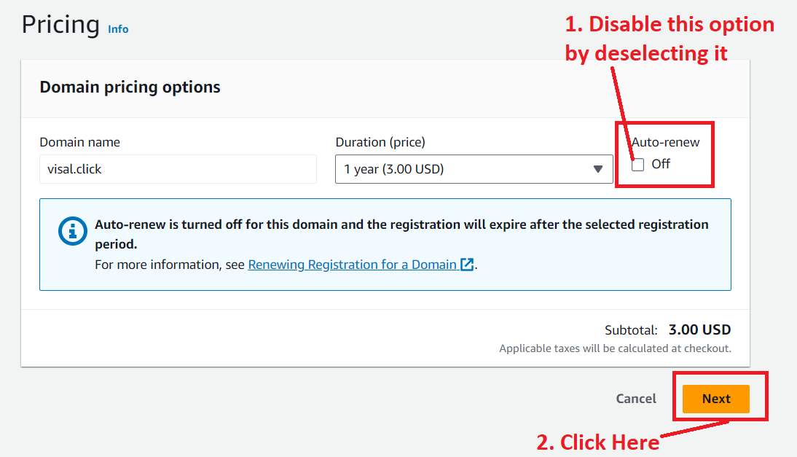

**Step 7: Put** your **contact information. I** am **putting** my **details** over **here & click** onthe **“Next”. (I am not showing the information here, but after putting details, I will click on the “Next”.)**

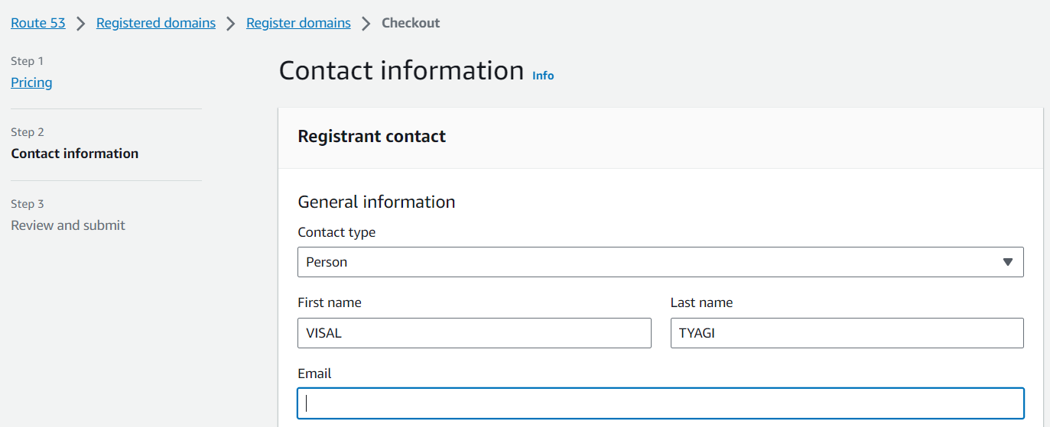

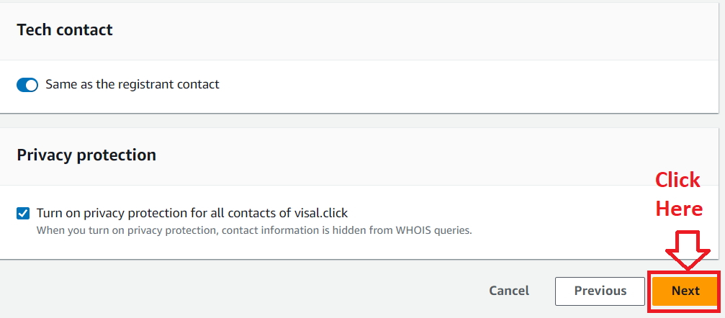

**Step 8: In** the **“Review & submit”, it** will **show** you **all** the **details. Select** the **“Terms & Conditions”** & **click** on **“Submit”.**

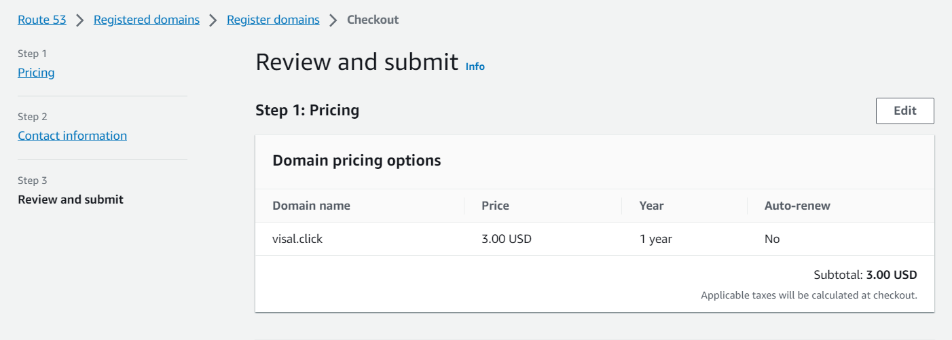

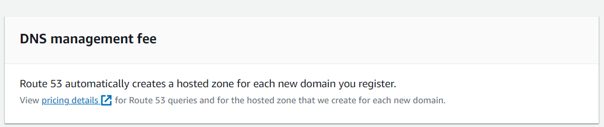

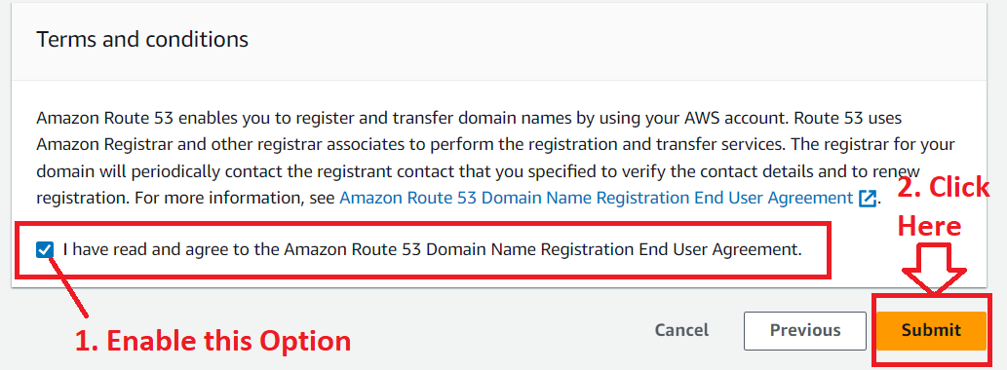

**Step 9: It** will **show** that **domain registration request** is in **“progress”** & **click** onthe **“Check Status”.**

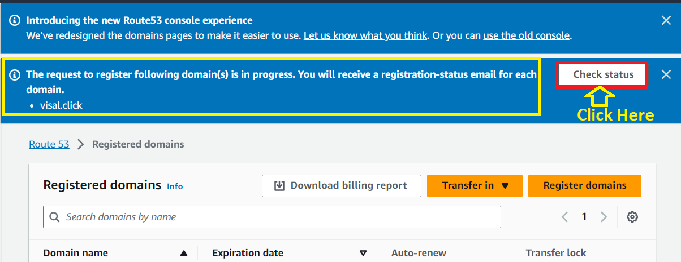

**Step 10: In** the **“Requests”, it** is **showing** the **“Action Required”** inthe **“Status”.**

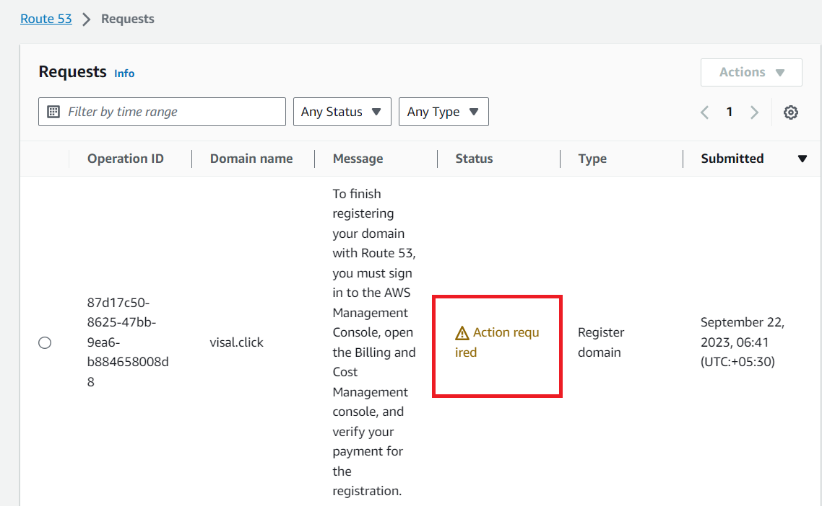

**Step 11: Select** the **Operation Id. Go** tothe **“Actions>Verify payment”.**

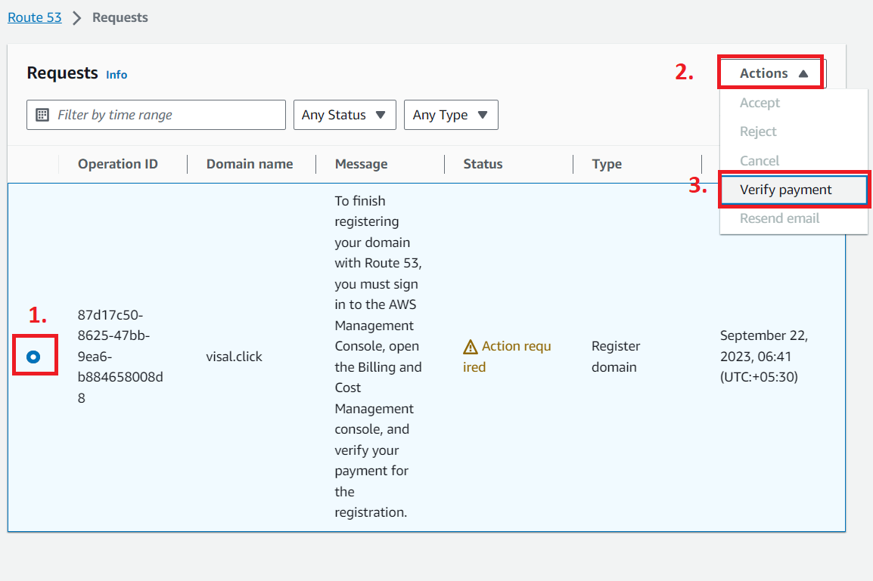

**Step 12: Click** onthe **“Complete Payment”.**

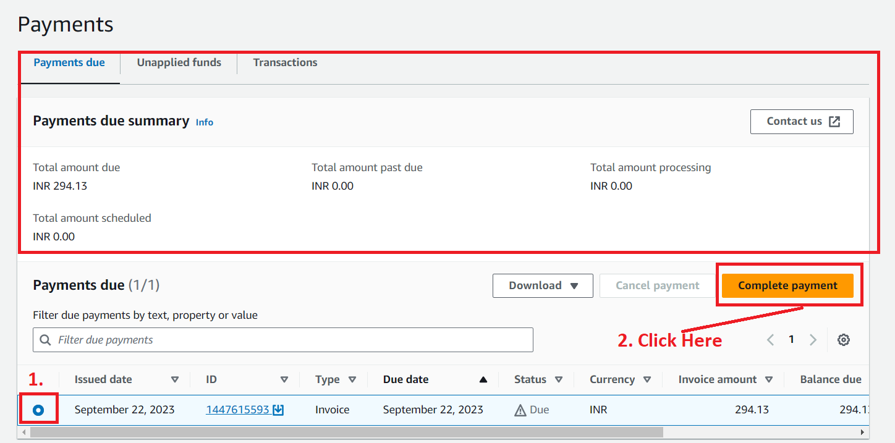

**Step 13: We** will **use debit card here. Click** onthe **“Use credit/debit card”.**

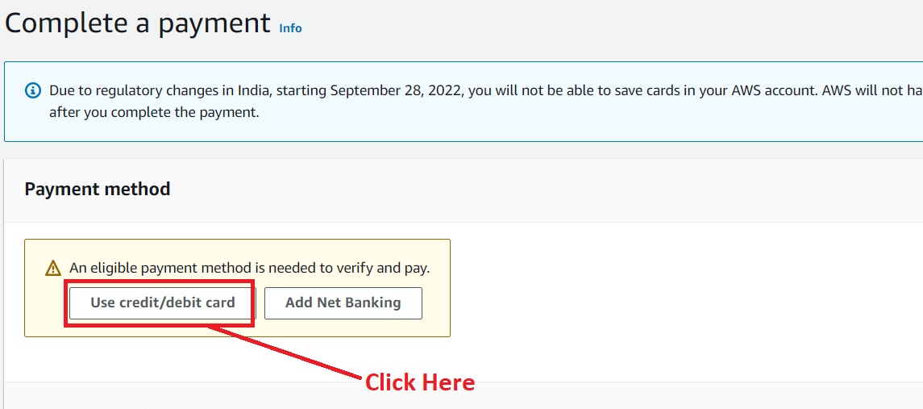

**Step 14: Add** your **card & contact address information** over **here & click** on the **“Next”.**

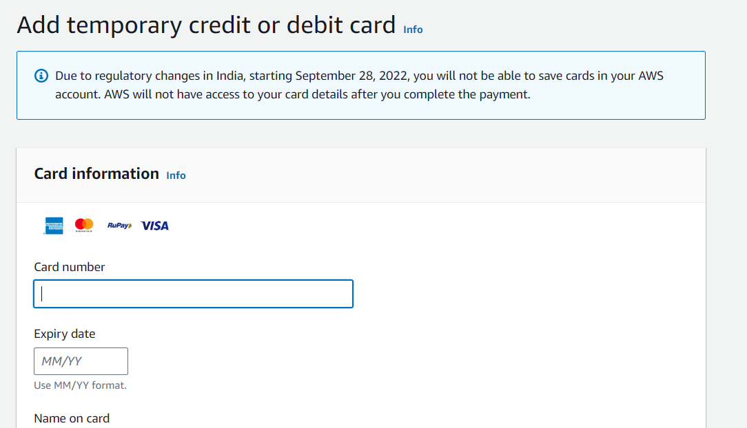

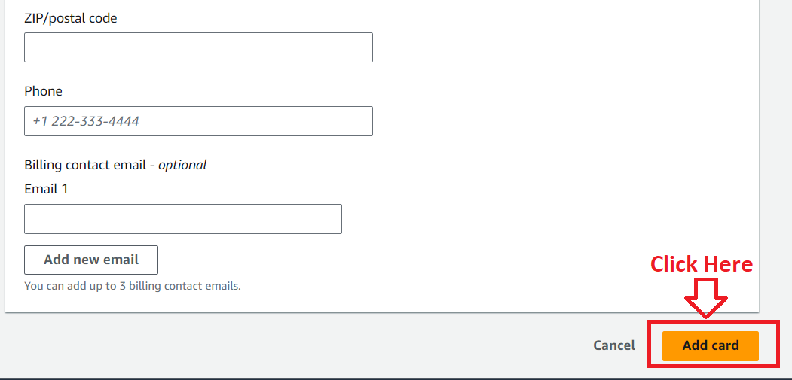

**Step 15: Now,** the **debit card** has been **successfully added. Enter** your **CVC here & click** onthe **“Verify and Pay”.**

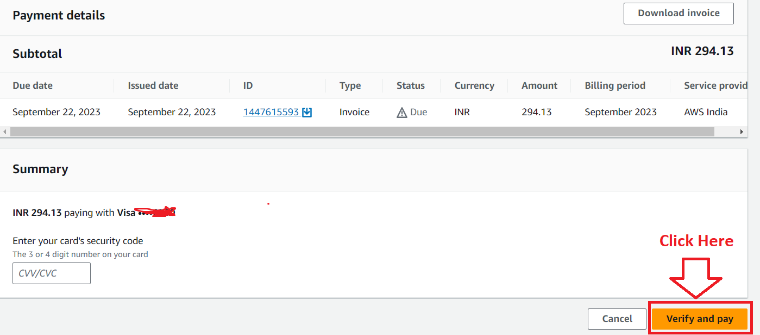

**Step 16: Click** onthe **“Proceed”.**

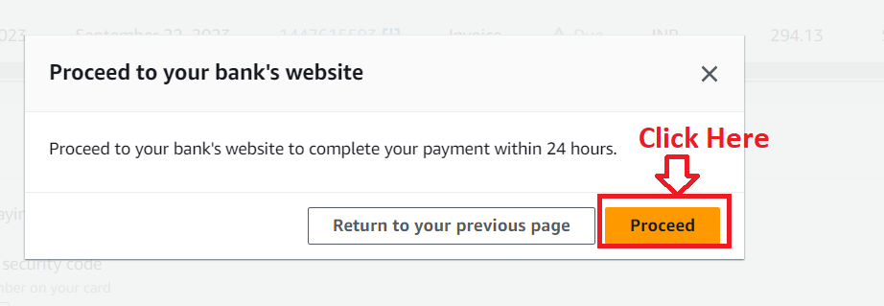

**Step 17: After completing** the **payment, “Successfully complete your payment” message** will be **shown.**

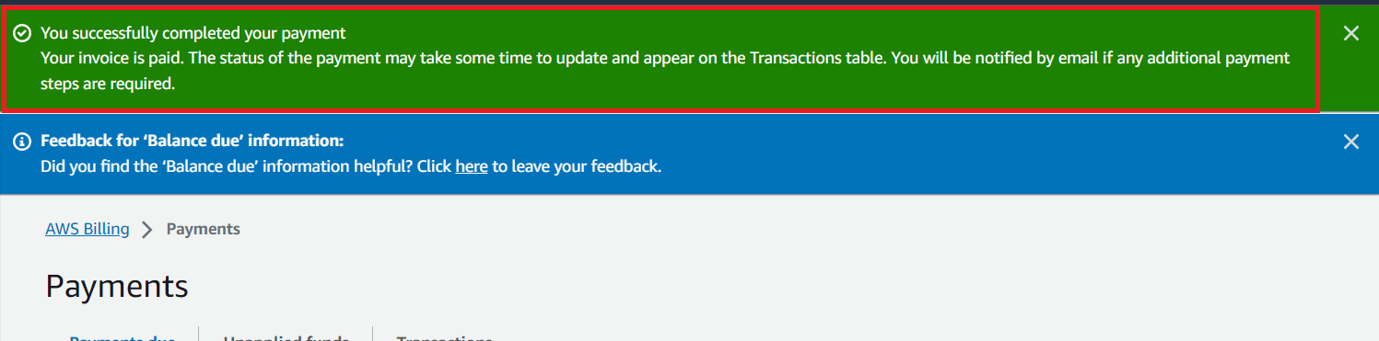

**Step 18: It** will **take some time** to **update** the **“payment status”. (Approx 1-5 minutes).**

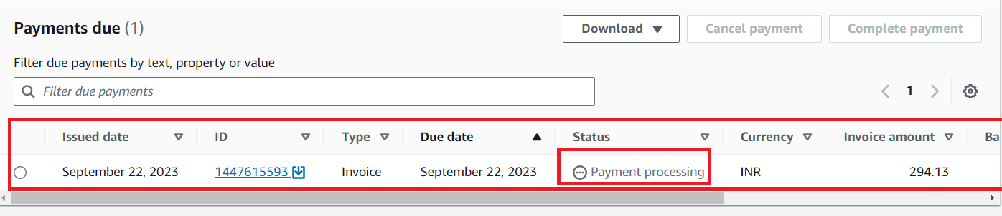

**Step 19: Go** to the **“Transactions”** & **your payment information** will be **shown like this;**

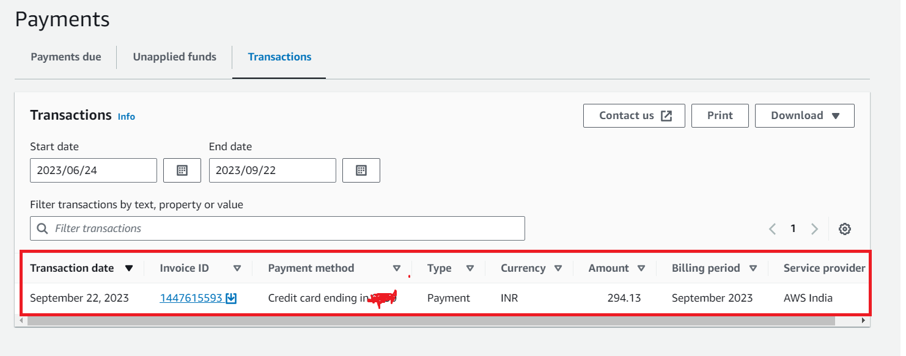

**Step 20: Search** the **“Route 53” again** inthe **“Services” section** & **click** onthe **“Route 53”.**

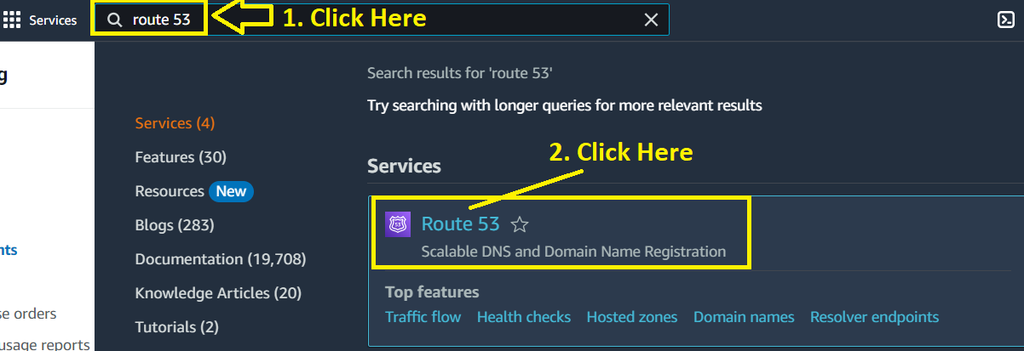

**Step 21: In** the **“Route 53 Dashboard”,** the **“Status”** is **shown** as **“Domain registration in progress”** under **“Notifications”** section**.**

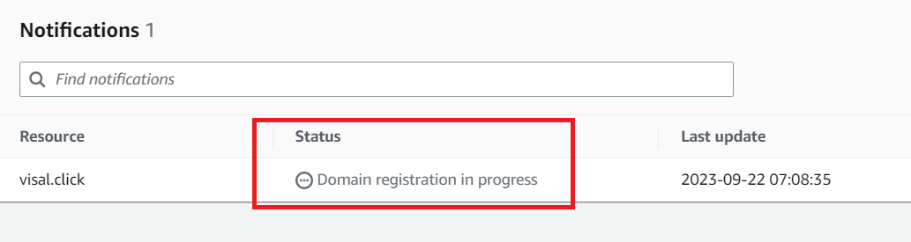

**Step 22: Amazon Web Services** will **send you** a **mail** to **confirm** the **email address** for your **domain (visal.click). Open** this **email** by **clicking** on **it.**

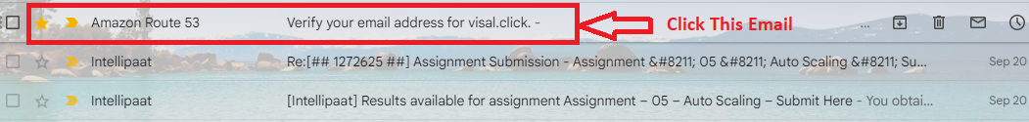

**Step 23: Click** on **the given link** in **the “Gmail”** for **verifying** the **email address.**

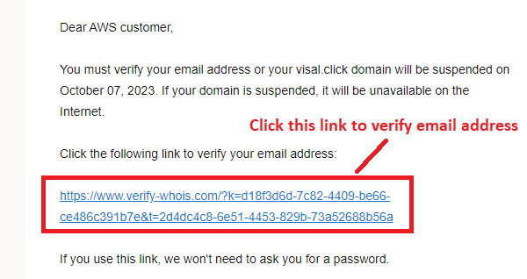

**Step 24: A “Thank You” Message** for **Email Id Confirmation** will be **shown** in the **another tab.**

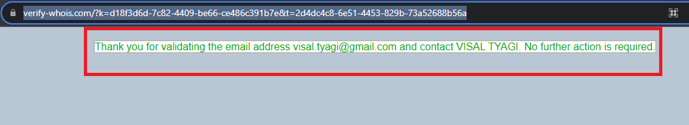

**Step 25: Again, go** to **your Gmail** &the **email Address Verified** will **trigger** to **your inbox** like **this;**

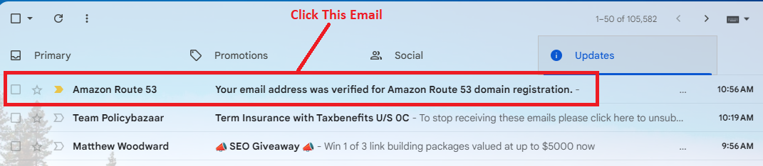

**Step 26: Click** on **this email** & **your email address** will be **successfully confirmed message** will be **shown here.**

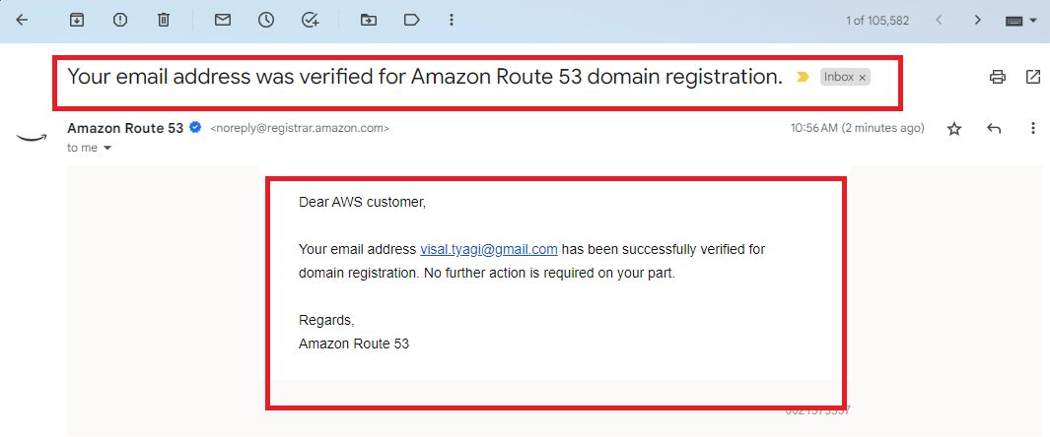

**Step 27: After sometime, you** will **get** an **email** from **AWS** that your **domain** is **successfully registered** & **set up** your **DNS records** now.

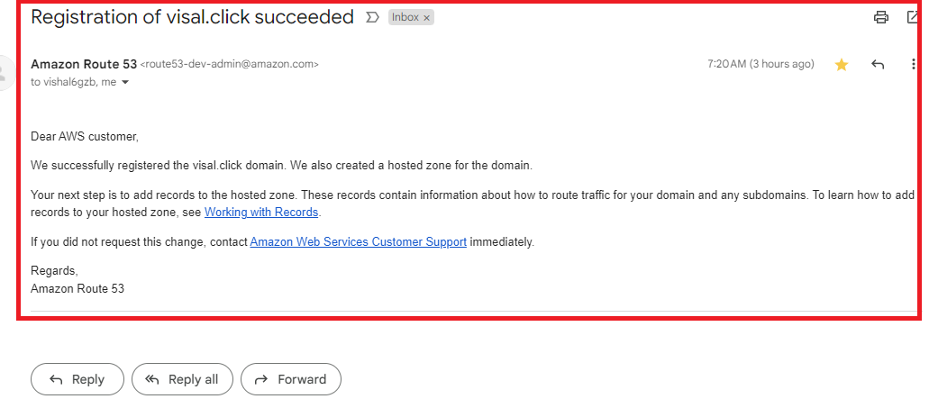

**Step 28: Now, go** tothe **“Amazon Route 53 dashboard”** & In the **“Notifications”** section, the **“Status”** is **shown** as the **“Domain Registration Successful”.**

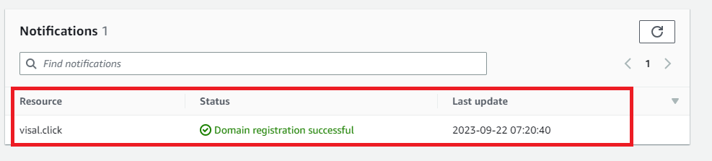

**Step 29: In** the **“Dashboard”, you** will see **“1 Domain is Registered** & **1 Hosted Zone Created”. Here, we don’t need** to **create** the **hosted zone manually. AWS Automatically creates** after **domain registration successful.**

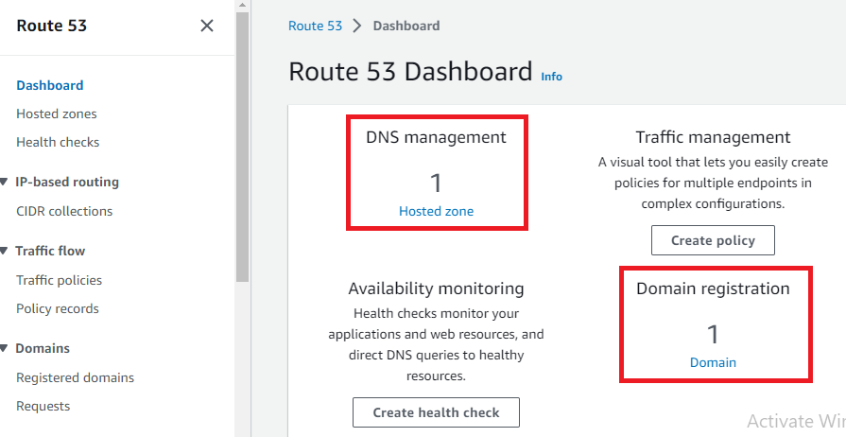

**Step 30: Go** to the **“Hosted Zones”.**

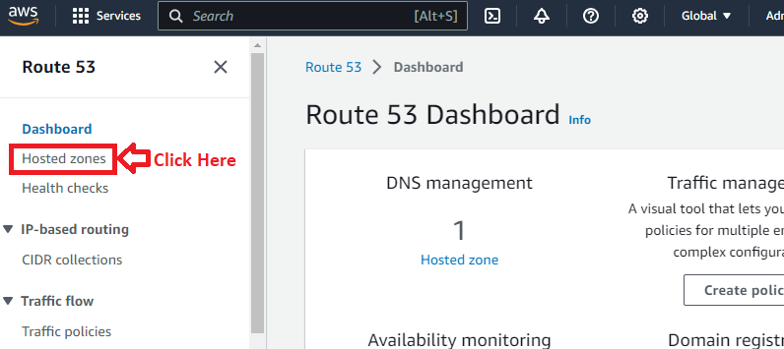

**Step 31: Your Automatically created hosted zone** will be **shown** & **you** can **view** your **DNS records details** here**.**

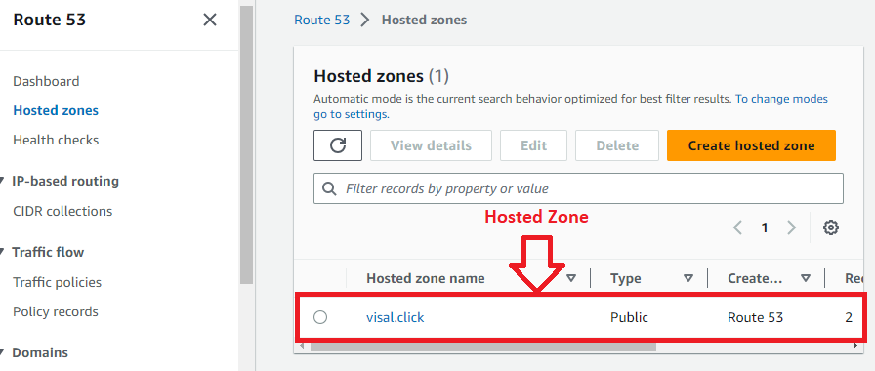

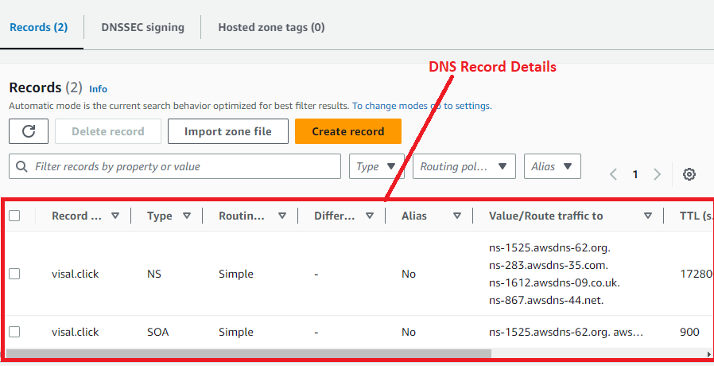

***Note: You can register a domain with other domain name providers like GoDaddy, Namecheap, Bigrock etc. But for domain outside, you have to create hosted zone manually & paste the DNS of AWS in that hosting provider DNS Configuration.***

**Problem 2 Solution:** Route the traffic to an EC2 instance with an Apache web server running in it using its IP address.

**a. Create an EC2 Instance with Apache Server Working on It**

**Step 1: Go** to the **“EC2”** section.

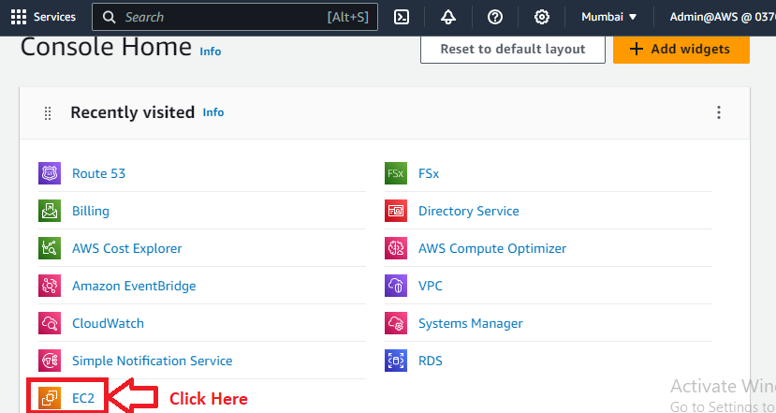

**Step 2: Click** on the **“Instances (running)”.**

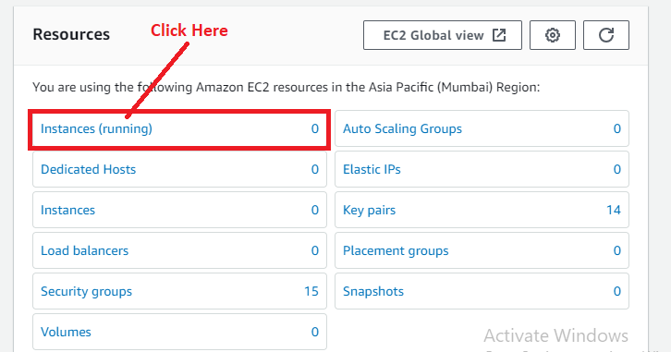

**Step 3: Click** onthe **“Launch Instances”.**

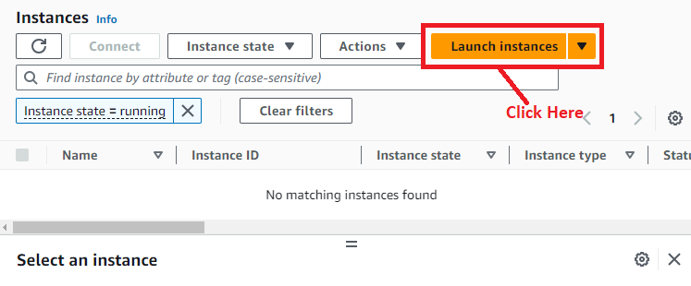

**Step 4: In** the **“Name and Tags”, choose** the **“Name”** asthe **“Route53Assignment”.**

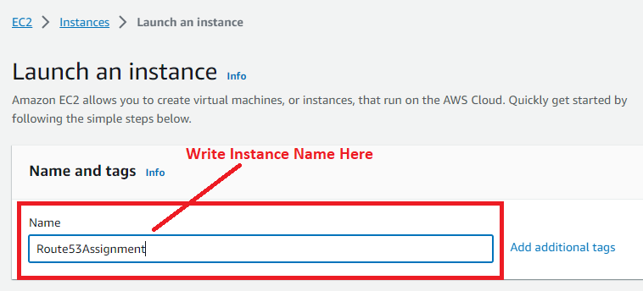

**Step 5: Choose** the **“Amazon Machine Image”** as the **“Amazon Linux”.**

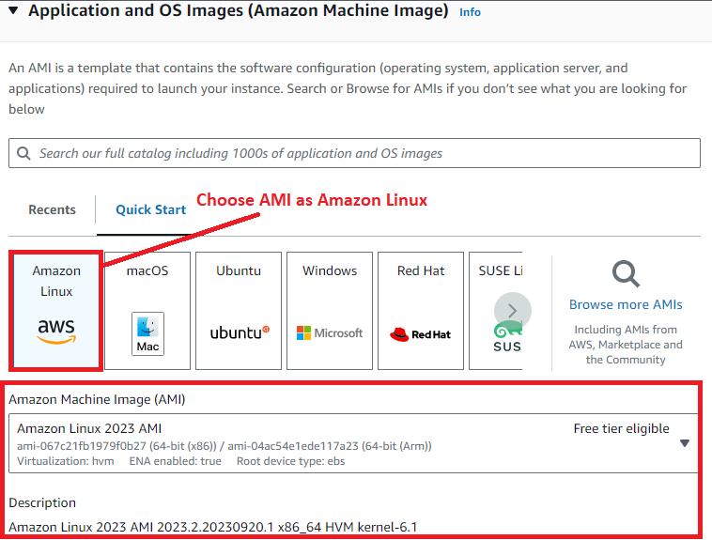

**Step 6: Choose** the **“Instance Type”** asthe **“t2.micro”.**

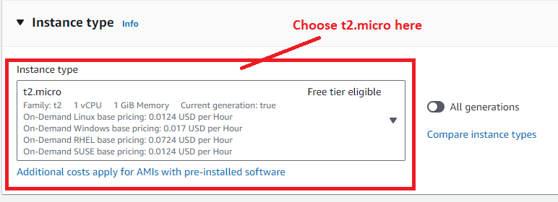

**Step 7: Choose** the **“Proceed without a key pair (Not recommended)** inthe **“key pair (login).**

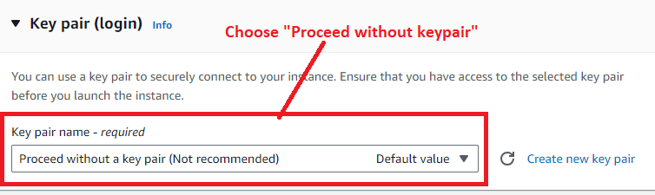

**Step 8: In** the **“Network Settings”, click** onthe **“Edit”.**

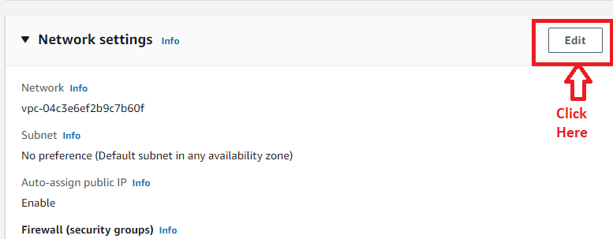

**Step 9: Choose** the **“Firewall (security groups)”** as **“Select existing security group”. While,** in the **“Common security groups”, choose** the **security group** as the **“launch-wizard-6”.**

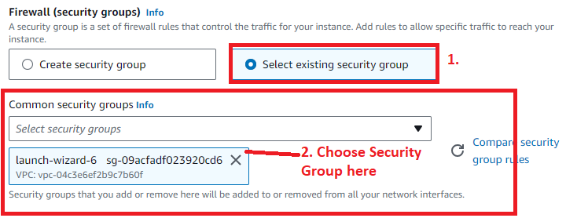

**Step 10: In** the **“Advanced Details”, put** the **below user data** to **install apache2 web server** onthe **Amazon Linux:**

**#!/bin/bash**

**yum update -y**

**yum install -y httpd.x86_64**

**systemctl start httpd.service**

**systemctl enable httpd.service**

**echo “Hello World from $(hostname -f)” > /var/www/html/index.html**

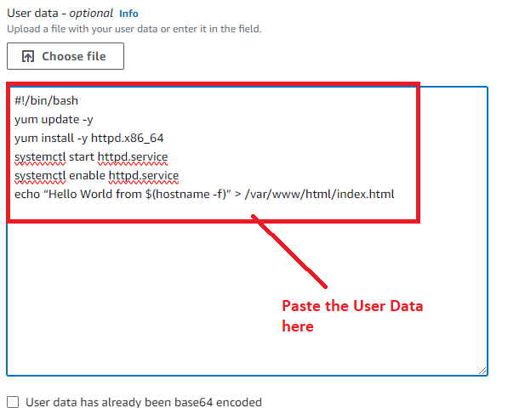

**Step 11: Click** onthe **“Launch Instance”.**

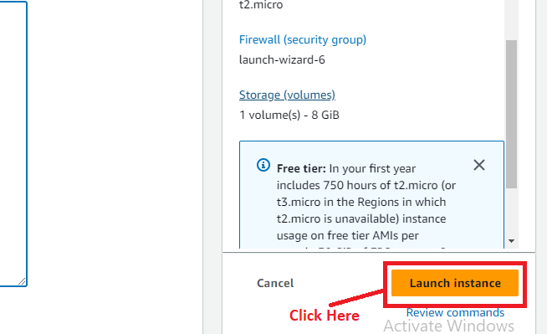

**Step 12: The instance** will be **successfully launched. Click** on the **“Hyperlink”** to **view** the **Instance.**

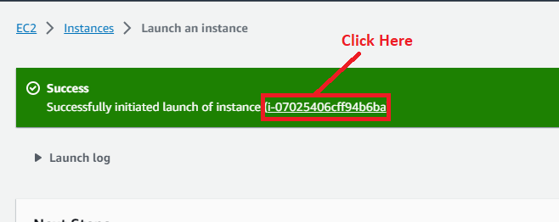

**Step 13: Your instance** will be **in** the **“Running” State** now**.**

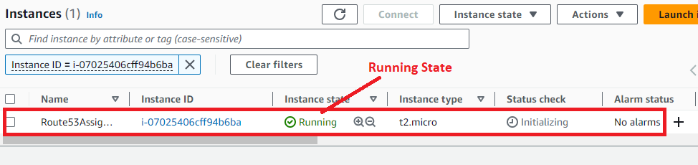

**Step 14: Select** the **Instance** & **click** onthe **“Open address”.**

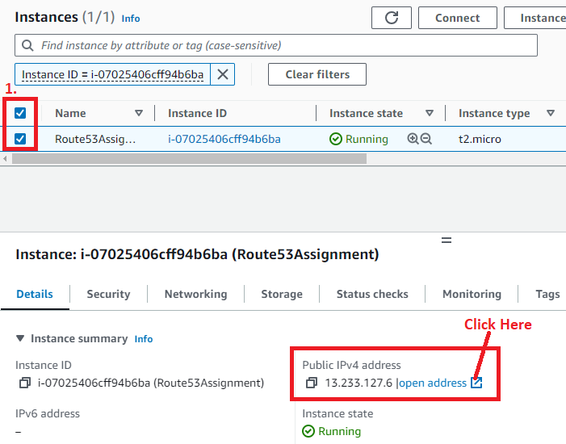

**Step 15: Your Apache Web Server** is **successfully installed** & **you** can **view your page** with **content.**

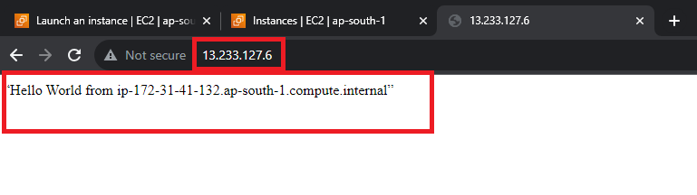

**b. Route the Traffic of EC2 Instance With IP Address to Domain Name (visal.click)**

**Step 1: Search** the **“Route 53”** & **go** to the **“Route 53>Hosted Zones”.**

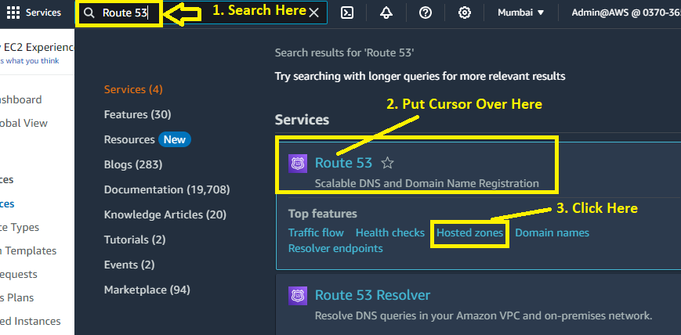

**Step 2: Click** on **your “domain name (visal.click)”** here**.**

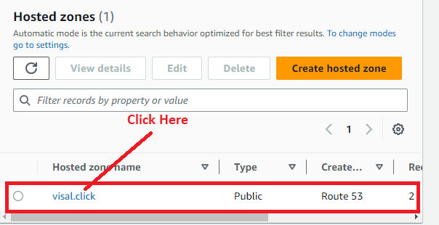

**Step 3: Click** onthe **“Create record”.**

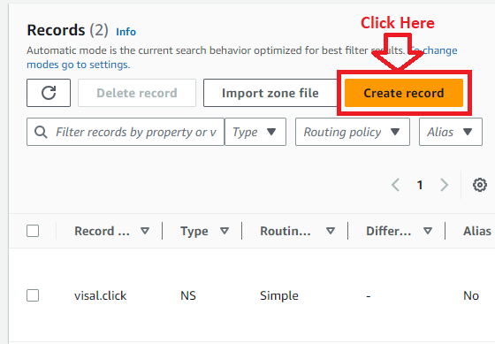

**Step 4: Put** your **EC2 Instance Apache Web Server IP Address (13.233.127.6)** inthe **“Value” section.**

**Record name –** Leave Blank

**Choose** the **“Record type”** asthe **“A- Route traffic to an IPV4 address and some AWS resources”.**

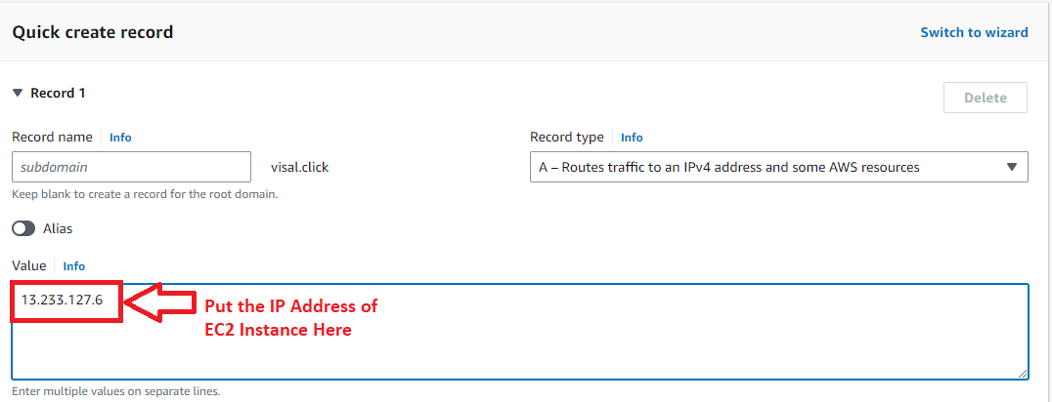

**Choose** the **“Routing Policy”** asthe **“Simple routing” & “TTL”** as **“300”.**

**Step 5: If we type** our **domain “visal.click”** inthe **browser address bar, nothing** will be **shown** as a **web page.**

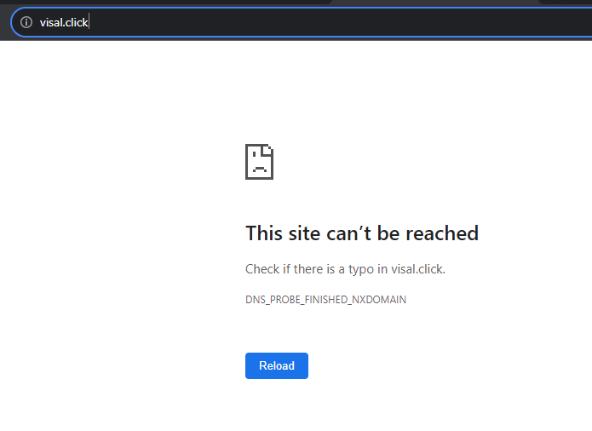

**Step 6: Now, we will go** tothe **“Create record”** section & **click** onthe **“Create records”.**

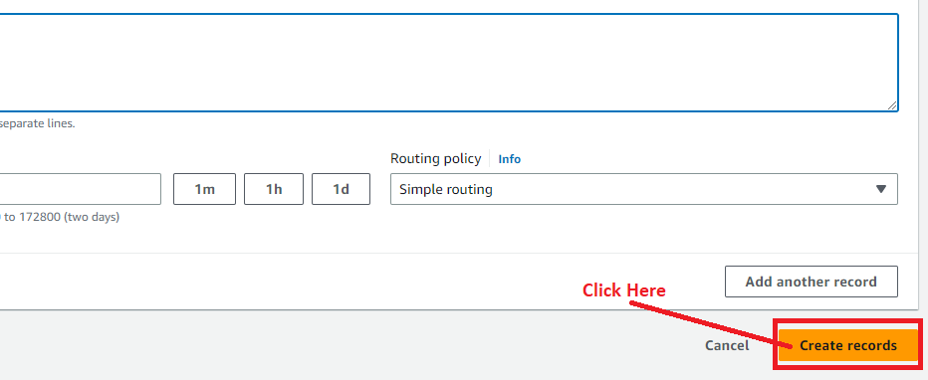

**Step 7: It** will **take “60 seconds”** to **route** the **EC2 Instance IP Address** to the **Domain.**

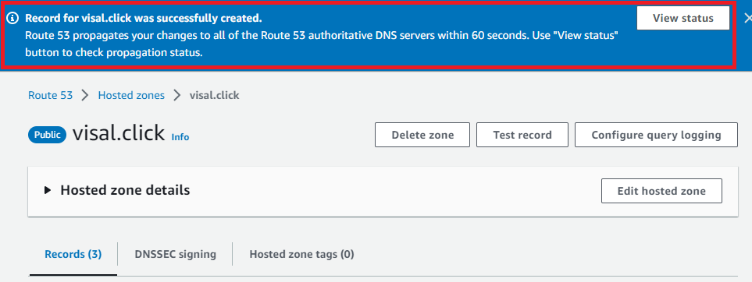

**Step 8: Click** on the **“View Status”.**

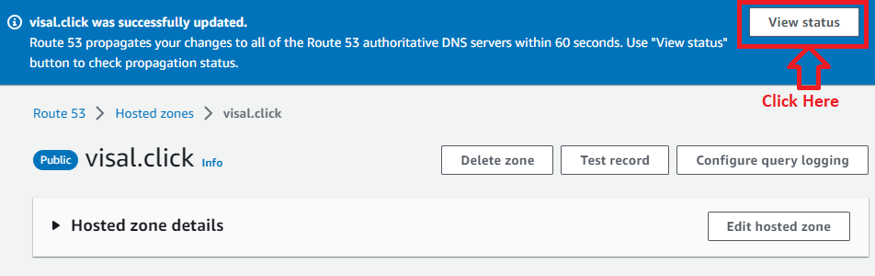

**Step 9: Your status** is **shown** as **“INSYNC”. It means** your **EC2 Instance Routing** to **Domain** is **successful.**

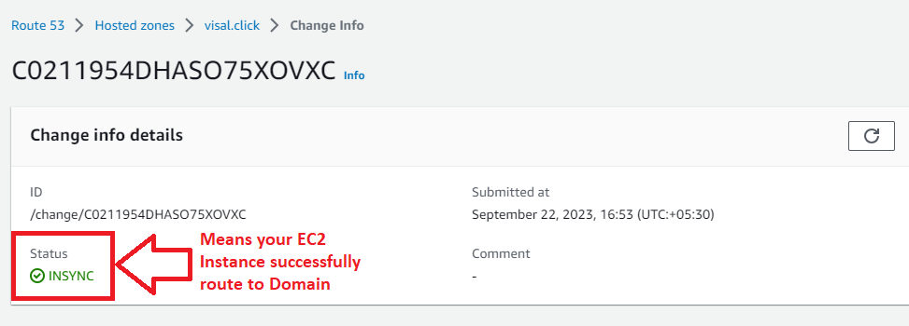

**Step 10: Now, go** to **new tab** in **browser** & **type “visal.click”** in **“browser address bar”. Your EC2 Instance content** will be **displayed** on **domain (visal.click).**

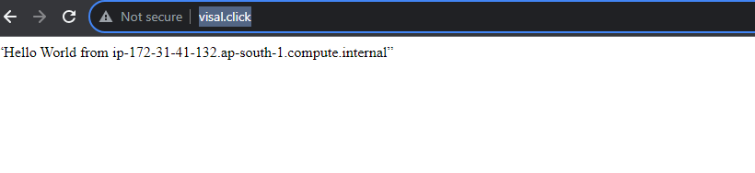

**So, this is the complete assignment of Route 53 to route the IP address to domain.**